





Hello Solidity – Writing First Smart Contract

Objective/Aim:
To learn the fundamentals of the Solidity programming language and gain practical experience in writing, compiling, and deploying a basic smart contract on the Ethereum blockchain.
Apparatus/Software Used:
- Laptop
- Solidity (v0.8.x)
- Remix IDE
- Metamask Sepolia testnet wallet

Theory/Concept:

What is a Smart Contract?
A smart contract is a self-running program stored on a blockchain that triggers and enforces actions when certain conditions are met. It removes the need for intermediaries by executing agreements automatically. We use Solidity to write these contracts for the Ethereum network.

What is Solidity?
Solidity is a high-level programming language used to build and deploy smart contracts on the Ethereum blockchain. It is designed to handle complex logic and ensures secure interactions between users and the blockchain.

Procedure:

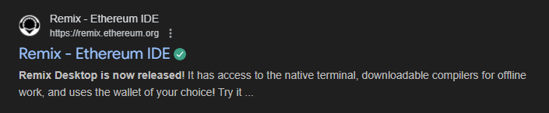
Step 1: Open Remix IDE on your browser
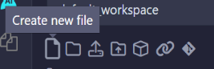

Step 2: Create a new file give the name of the file then add “.sol” for write the code in solidity
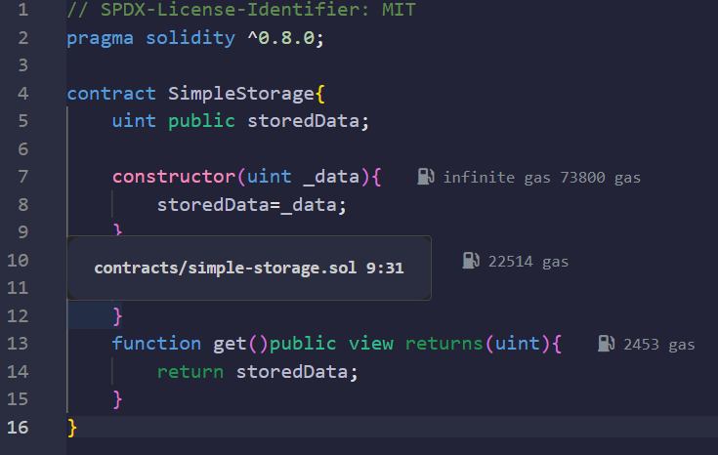
Step 3: Then write the code for the simple storage system

Step 4: Go to solidity compiler and compile the code
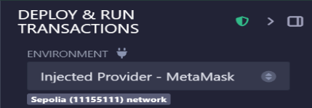
Step 5: Go to the deploy and run section , set the environment as injected provider and connected the wallet enter any data and deploy the transaction
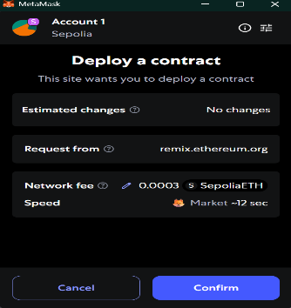
Step 6: Confirm the transaction and the first smart contract have been deployed

Observation Table:

Our first solidity smart contract deployed successfully.

